
DEVELOPMENT SOFTWARE PROJECT DOCUMENTATION
STUDENT DETAILS:
MD MBEWE 224045548
I MOTAUNG 220113847
K SEBOKOANE 224009153
T NETHAVHAKONE 222234247
K MABENA 225072705
TP MALINGA 225215605

Contents
Project Overview 4
5.USE CASE DIAGRAM 7
6.USE CASE DESCRIPTIONS 8
7.ACTIVITY DIAGRAMS 11
8.NAVIGATION STRUCTURE 14
9.USER EXPERIENCE FLOW 16
SYSTEM REQUIREMENTS 19
OVERVIEW OF FUNCTIONS AND NON-FUNCTIONS 19
SEQUENCE DIAGRAM(S) 20
UML DIAGRAM 23
SYSTEM ARCHITECTURE DIAGRAM 24
API REQUIREMENTS (Table format) 24
Internal Backend Routes Using This API: 26
Internal Backend Routes Using This API 27
Email Types 28
Internal Backend Routes Using This API 30
Internal API Routes (Backend) 30
Authentication Routes 30
Admin Routes 31
Materials Routes 32
Transactions Routes 32
Locations Routes (Google Maps API) 33
Rewards Routes 33
Health Check 33
Authentication Details 34
HTTP Status Codes 34
DESIGN JUSTIFICATION 35
SLOTTING DIAGRAM 36
USER INTERFACE 37
RESPONSIVENESS 38
CONCLUSION 38

Project Overview
1.Introduction
Ecocyle is a web-based application designed to support recycling buy-back centres and informal waste pickers in South Africa. The platform aims to improve environmental sustainability by creating a more organized and transparent recycling system. It provides a digital solution for recording recyclable material transactions, managing waste picker information, and tracking income generated through recycling activities.
The system also seeks to recognize and support the important role played by informal waste pickers in reducing environmental pollution and promoting recycling within communities.
2.Problem statement
Environmental sustainability remains a significant issue due to the increasing in pollution, waste accumulation, and the poor waste management practices. Informal recycling in South Africa plays a unique role in reducing environmental damage through the efforts of informal waste pickers, who sort through vast amounts of waste in the streets and hazardous environments to collect recyclable materials that can be used to produce new materials and products.
Many recycling buy-back centres do not have structured systems to track recyclable materials, waste picker information, or financial transactions. As a result, waste pickers often experience unstable income, lack formal identification within the system, and face limited financial transparency.
Organisations such as recycling buy back centres purchase recyclable materials from waste pickers but maintain extraordinarily little documentation regarding the materials that are collected, who supplied them and the related financial transactions.
These challenges create the need for formalized record keeping, improved financial transparency, data driven insights within the informal recycling sector.
3.Business Requirements
- The system must allow buy-back centres employees to register waste pickers to personal information.
- The system must allow recycling buy-back centres to record recyclable material transactions.
- The system must calculate and record payments made to waste pickers.
- The system must provide transparency in recyclable material pricing.
- The system must generate income tracking for waste pickers.
- The system must display environmental statistics and recycling trends.
- The system must integrate Google Maps API to display recycling buy-back centre locations and activity.
- The system must securely store user and transaction data.
- The system must be accessible through desktop and mobile devices.
- The system must reward the highest contributors to support and encourage waste picker participation in recycling activities which is managed by employees.
4.User-Roles and Divisions
System Administrator (super admin): Monitor environmental data, view AI material trends, manage system-wide insights, and oversee platform functionality.
Administrator (Buyback Centre Manager): Responsible for overseeing recycling centre operations and monitoring system data. Manage recyclable material prices, monitor transactions, view income reports, and access environmental dashboards.
Buyback staff (Employee): Register waste pickers, record recyclable material transactions, update system records , manage reward tracking for waste pickers .
Additional Stakeholders:
Waste pickers are beneficiaries of the system whose information and transactions are managed by buy-back centre staff through the platform. This approach was chosen because many informal waste pickers may have limited access to smartphones, internet connectivity, or digital literacy, making direct interaction with the system difficult. The platform therefore allows recycling centre staff to manage and capture information on their behalf.

5.USE CASE DIAGRAM
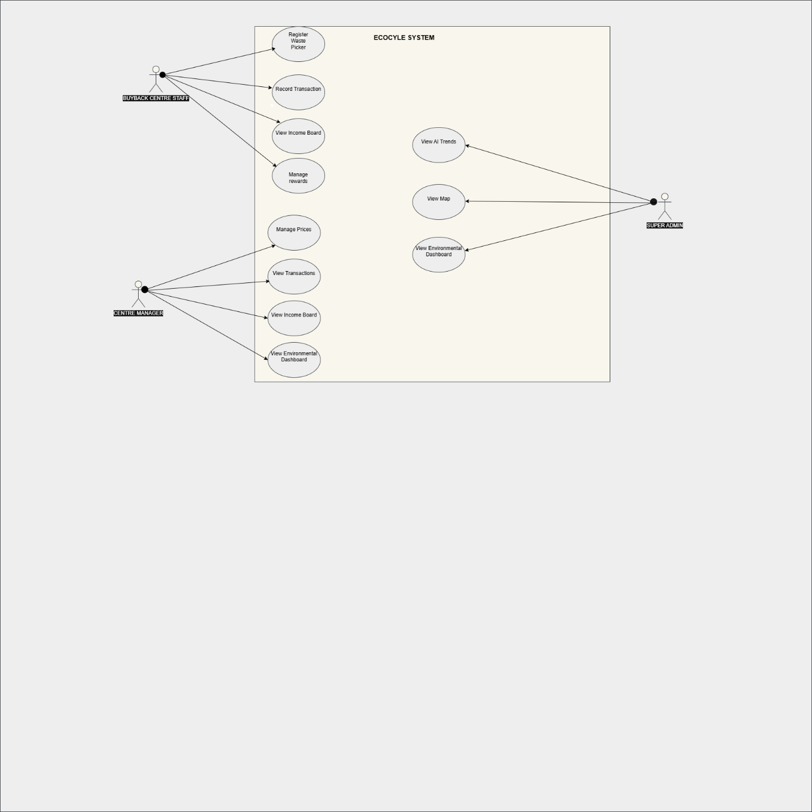

6.USE CASE DESCRIPTIONS

USE CASE Name | Register waste picker
ACTOR | Buyback centre employees
DESCRIPTION | It allows the buyback centre employees to register waste pickers and store their information in the system
PRE CONDITION | The employee must be logged in the system to do this
POST CONDITION | The waste picker information is stored in the system in the database

USE CASE Name | Record transaction
ACTOR | Buyback centre employees
DESCRIPTION | It allows the buyback employees to record recyclable materials that are brought by waste pickers and calculates payments
PRE CONDITION | The waste picker must already be registered in the system
POST CONDITION | Transaction information are saved in the system successfully

USE CASE Name | Manage Prices
ACTOR | Admin (centre manager)
DESCRIPTION | It allows the admin to set and update prices within the system
PRE CONDITION | The manager must be logged in the system to do this
POST CONDITION | The updates are saved and applied to future transactions

USE CASE Name | View Environmental Dashboard
ACTOR | Admin(centre manager),Super admin
DESCRIPTION | It allows the users to monitor environmental statistics and recycling data
PRE CONDITION | The Admin must be logged in the system to do this
POST CONDITION | Environmental statistics are displayed successfully

Use Case Name | View AI trends
Actor | Super Admin
Description | Allows the administrator to view AI-generated material trend insights.
Pre-condition | User must be logged into the system.
Post-condition | Material trend insights are displayed successfully.

Use Case Name | Manage rewards
Actor | Buyback centre staff(employees)
Description | Allows the employees to manage and track rewards incentives belonging to waste pickers
Pre-condition | Buyback centre staff must logged in the system
Post-condition | Reward information is updated successfully in the system

Use Case Name | View Income board
Actor | Admin , super admin
Description | Allow users to view waste pickers earnings and statistics
Pre-condition | User must logged in the system
Post-condition | Income information is displayed successfully

Use Case Name | View Map
Actor | super admin
Description | Allows the super admin to view the locations of buyback centres
Pre-condition | Super admin must logged in the system
Post-condition | Buyback centre location are displayed successfully

7.ACTIVITY DIAGRAMS
1.RECORD TRANSACTION
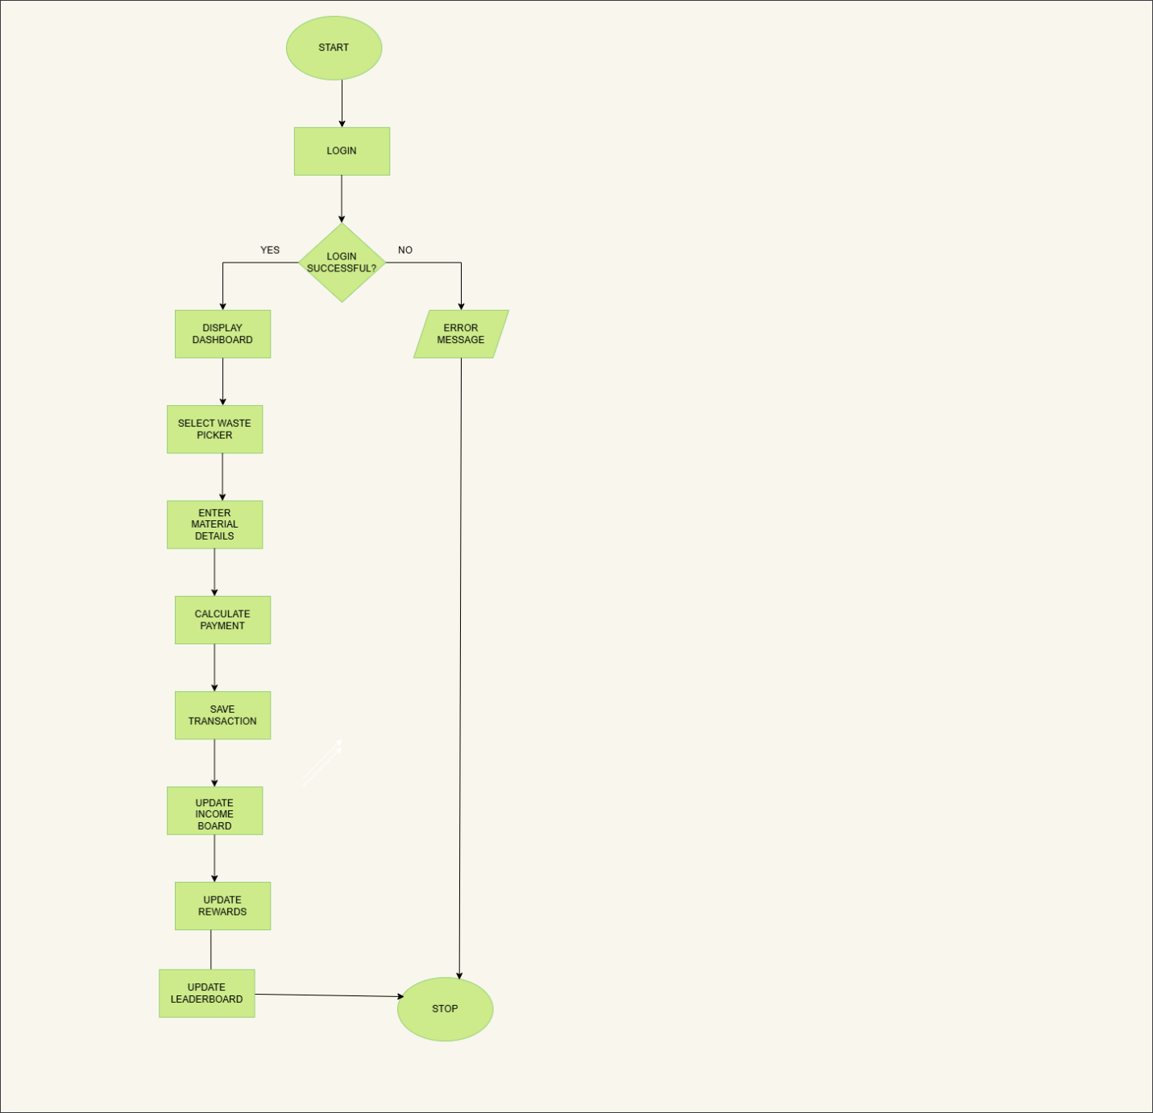

2. RECORD WASTE PICKER
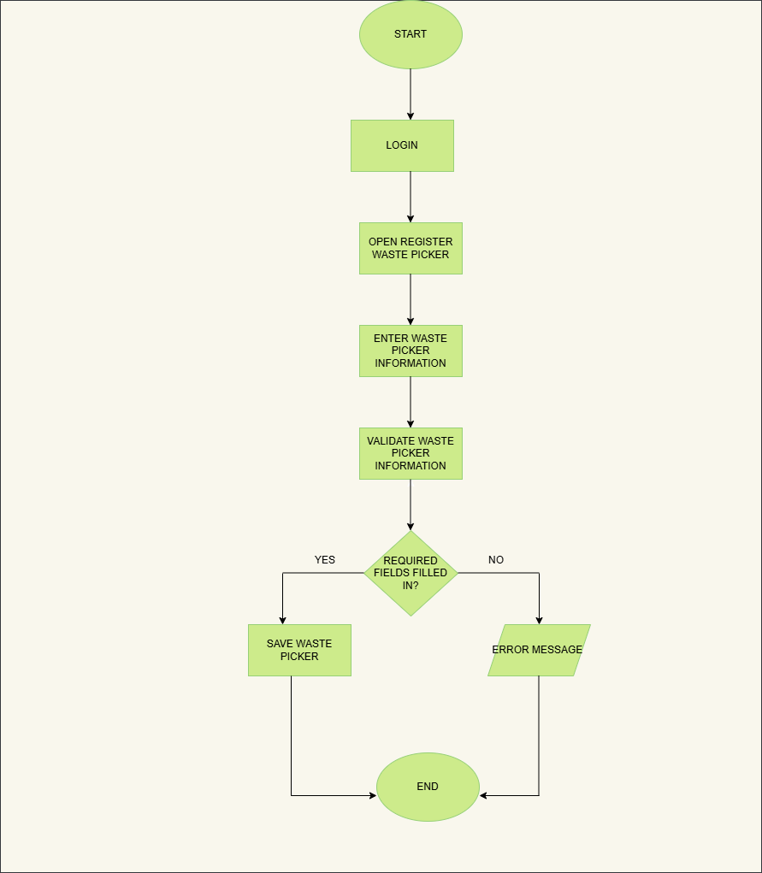

3.MANAGE REWARDS
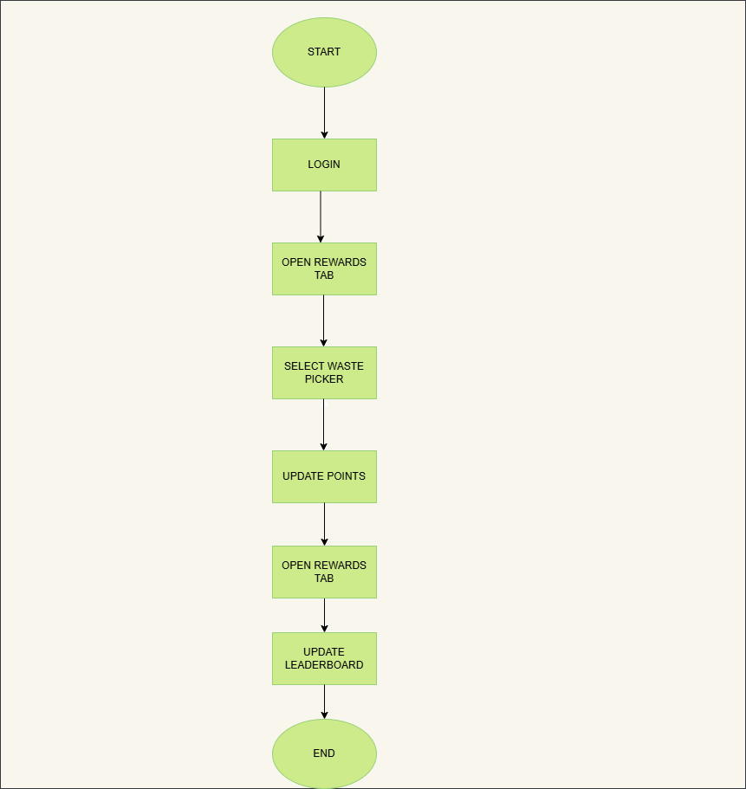

8.NAVIGATION STRUCTURE
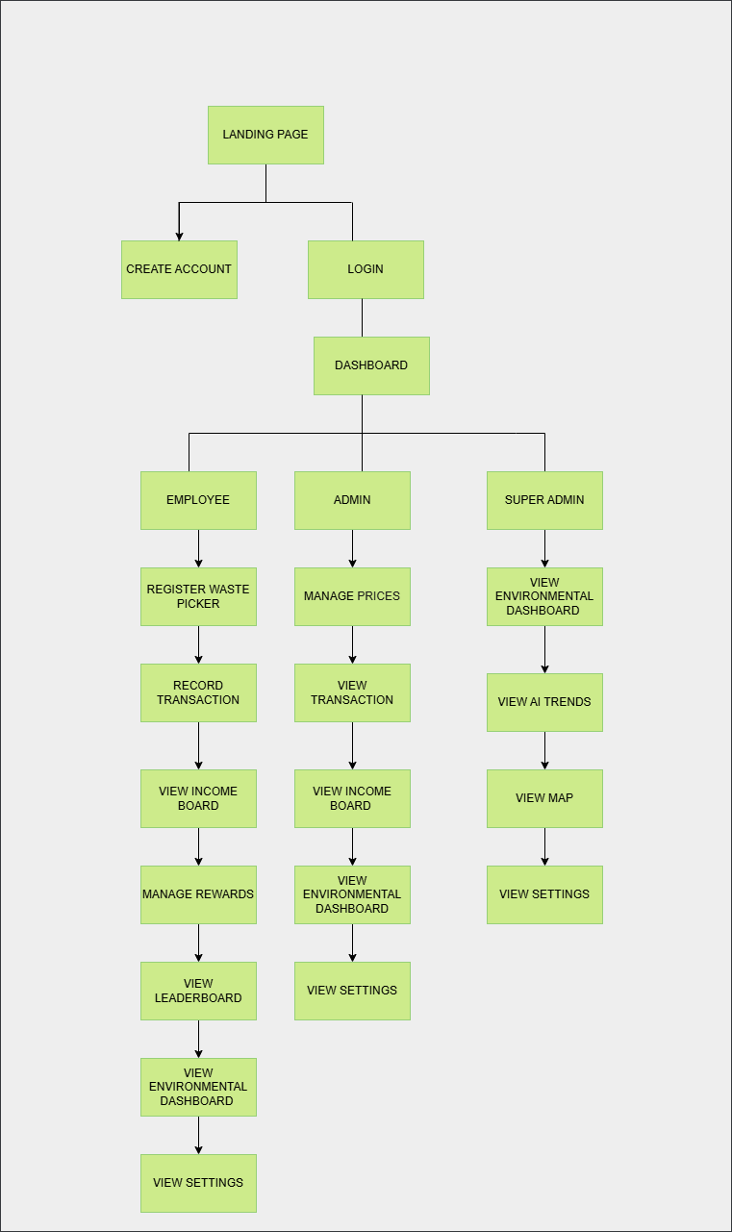
The EcoCycle navigation structure follows a role-based hierarchy. After successful authentication, users are directed to a dashboard where system functionality is displayed according to their assigned role. This ensures users only have access to features relevant to their responsibilities within the recycling management process.

9.USER EXPERIENCE FLOW

The following diagram shows user experience flow which illustrates the journey followed by Buy-Back Centre Staff when registering waste pickers, recording transactions, and managing rewards within the EcoCycle system:
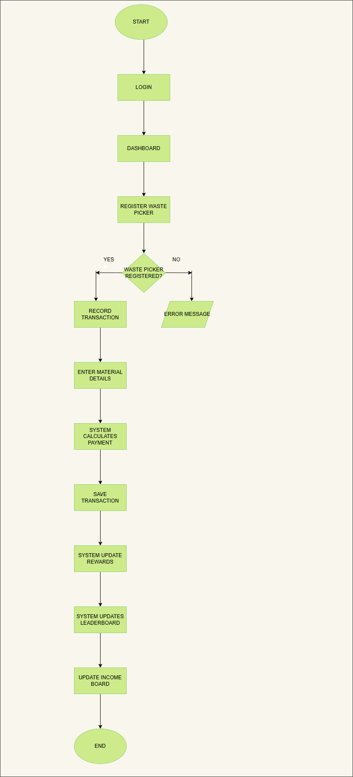
2. The following diagram shows user experience flow which illustrates the journey followed by the Administrator(Centre manager) when managing material prices, viewing the income board within the EcoCycle system:
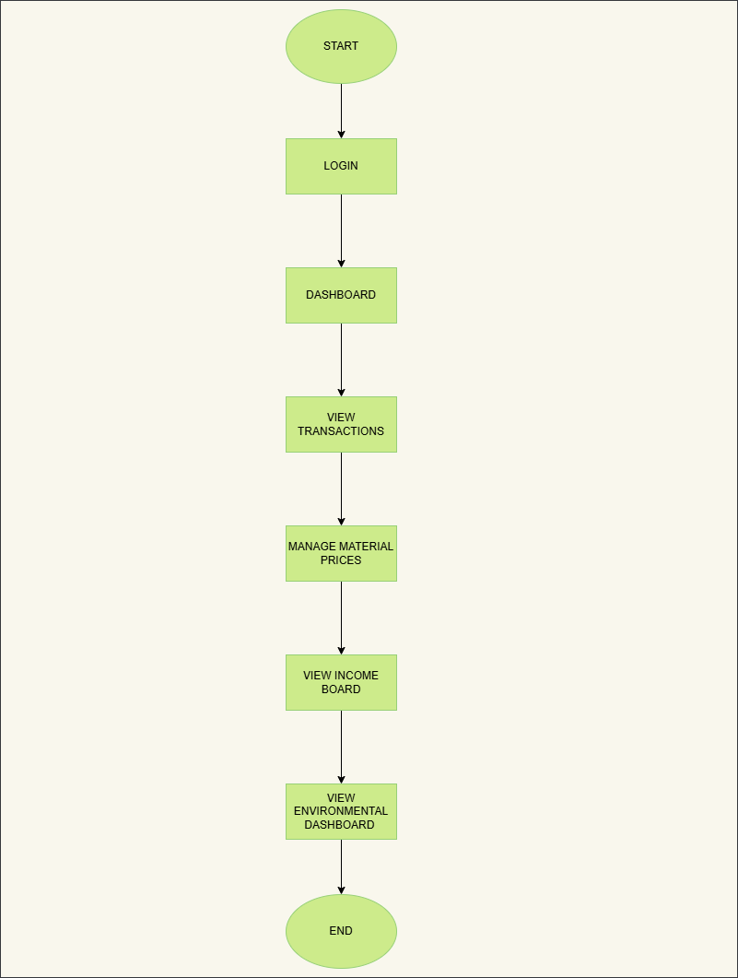
The following diagram shows user experience flow which illustrates the journey followed by the Super Admin when viewing the map, material trends and buyback centre map that shows current activity:
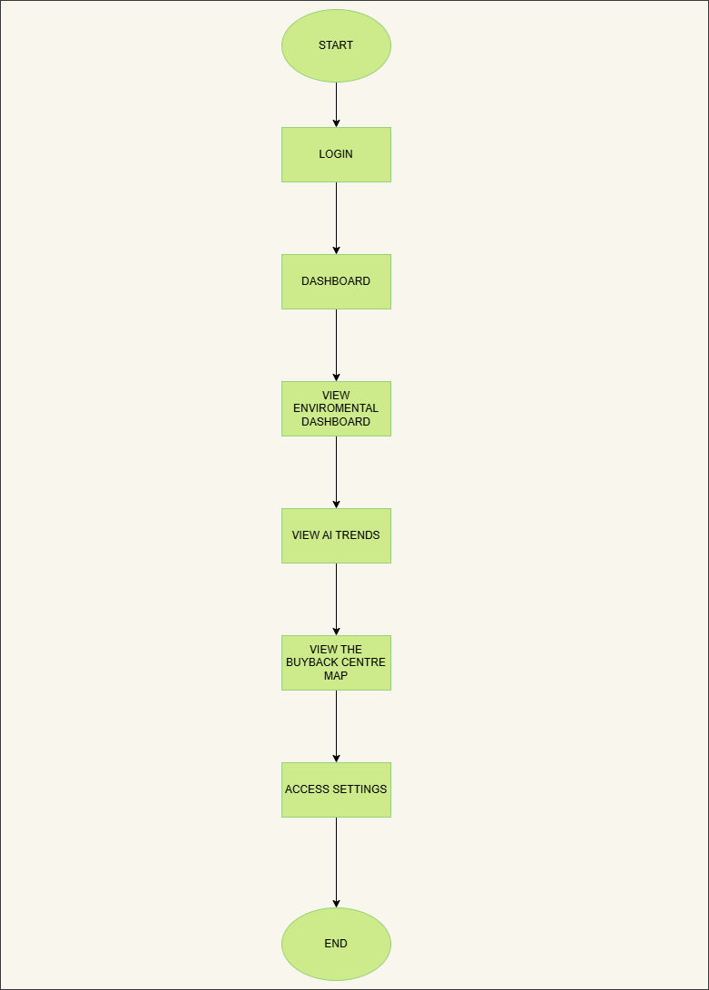

SYSTEM REQUIREMENTS
- Functional Requirements
- System shall allow waste pickers to register at a buy-back centre (name, ID number, phone number).
- System shall enable buy-back centre staff to record each recyclable material transaction (picker, material type, weight/quantity, price, total paid).
- System shall maintain a price list for recyclable materials (per kg or per unit).
- System shall calculate and display an income board for each waste picker (daily, monthly, total).
- System shall generate an environmental dashboard with monthly material collected and the overall environmental impact.
- System shall provide an AI-based material trend tracker showing which materials are increasing in volume and demand.
- System shall integrate a Google maps API to display buy-back centre locations.
- System shall support three roles: User (buy-back centre staff), Admin, Super Admin.
- Non-Functional Requirements
- AI trend predictions refresh daily (off-peak hours).
- System must handle up to 50 concurrent buy-back centre users.
- Page load time must be less than 5 seconds.
- All financial transactions and any system changes must be recorded/logged.
- Environmental dashboard refreshes monthly

OVERVIEW OF FUNCTIONS AND NON-FUNCTIONS
Functions:
- Register waste pickers
- Record transactions
- Update material prices
- View earnings by picker
- View monthly material leaders on the income dashboard
- View trending materials on AI trend tracker
- Google Maps API shows centres with statistics
- Three roles allow access to the app/system.
Non-Functions:
- User/Admin can register waste pickers
- Only Admin/super Admin can edit prices
- System handles 50+ buy-back centres concurrently
- The system refreshes daily
- There is strict access control for each user
- The app is responsive for all mobile users

SEQUENCE DIAGRAM(S)
- User registration and authentication
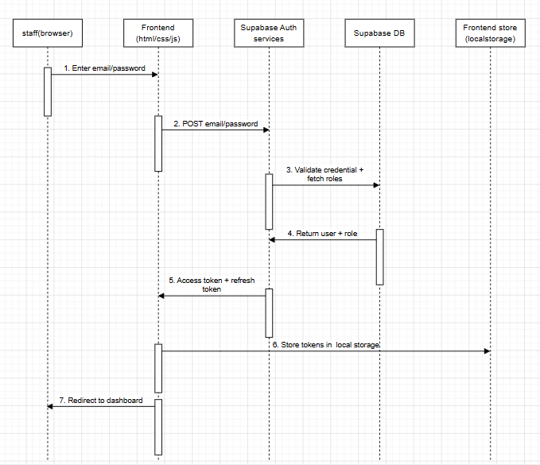
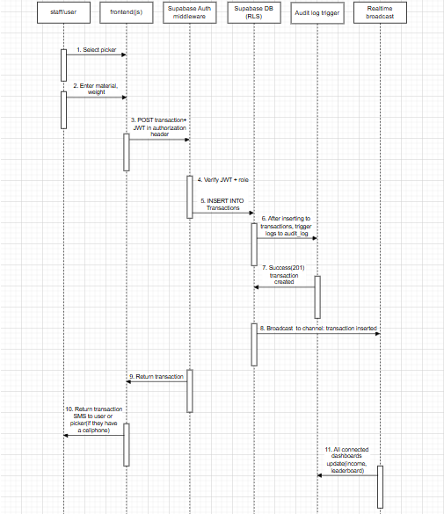
- Recording a transaction

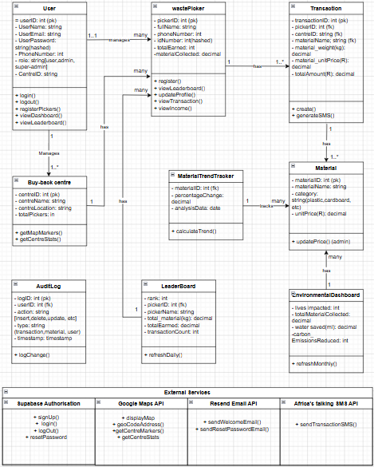
UML DIAGRAM

SYSTEM ARCHITECTURE DIAGRAM
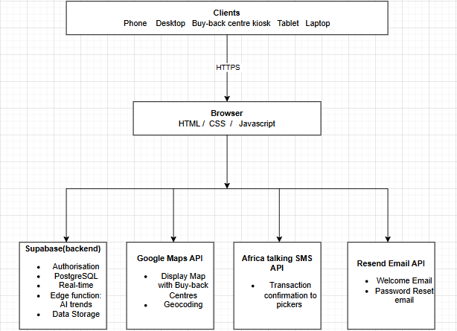

API REQUIREMENTS (Table format)
API Integrations Overview
EcoCycle integrates three external APIs to provide real-time location mapping, email communication, and SMS notifications. These APIs enhance the platform's functionality and enable it to interact with external services beyond the core application logic.
API 1: Google Maps Geocoding API
API requirements:
Property | Details
Provider | Google Cloud Platform
API Name | Google Maps Geocoding API
Base URL | https://maps.googleapis.com/maps/api/geocode/json
Authentication | API Key (stored in server .env as GOOGLE_MAPS_API_KEY)
HTTP Method | GET
Required Parameter | address — the place name to geocode
Required Parameter | key — your Google Maps API key
Optional Parameter | countrycodes=za — restrict results to South Africa
Response Format | JSON
Cost | Free tier — $300 Google Cloud credits
Rate Limit | 50 requests per second
Caching | 24-hour server-side cache to minimise API calls
Status | Active and fully integrated

Internal Backend Routes Using This API:
Method | Endpoint | Description
GET | /api/locations | Returns all 6 zones with real Google Maps coordinates + depot locations
GET | /api/locations/region/:id | Returns real coordinates for a single zone by ID
GET | /api/locations/depots | Returns depot locations only (hardcoded, no API call)

How it works:
- Backend calls Google Maps API on GET /api/locations request
- Results are cached for 24 hours to avoid redundant API calls
- If API fails, hardcoded fallback coordinates are used automatically
- Frontend SuperAdminMap.js reads from /api/locations and places markers on the map
- API key is stored securely in .env — never exposed to the browser
API 2: Resend Email API
API requirements:
Property | Details
Provider | Resend (resend.com)
API Endpoint | https://api.resend.com/emails
Authentication | API Key in Authorization header (Bearer token)
HTTP Method | POST
Content-Type | application/json
Required Fields | from, to, subject, html
Node.js Package | resend (npm install resend)
Cost | Free tier — 3,000 emails per month
Rate Limit | 2 requests per second on free tier
From Address | EcoCycle <onboarding@resend.dev> (testing mode)
Production Requirement | Verified domain (e.g. ecocycle.co.za)
Status | Integrated — domain verification needed for production

Internal Backend Routes Using This API
Method | Endpoint | Description
POST | /api/auth/register | Triggers welcome email after successful account creation
POST | /api/auth/forgot password | Triggers password reset email with secure token link
POST | /api/auth/reset-password | Validates token and resets password (no email sent)

Email Types
Property | Details
Welcome Email | Sent on registration — subject: "Welcome to EcoCycle!"
Password Reset | Sent on forgot-password — subject: "Reset Your EcoCycle Password"
Reset Link Format | http://localhost:3000/reset-password?token={token}
Token Expiry | 1 hour — token is invalidated after use

How it works:
- User submits Forgot Password form → POST /api/auth/forgot-password called
- Backend generates a unique secure token and saves it with 1-hour expiry
- Resend API called to send HTML email with reset link to user's email
- User clicks link → taken to reset password page → enters new password
- Token is cleared after use — cannot be reused
- Welcome email sent automatically on every new registration
- API key stored in .env — never exposed to frontend
API 3: Africa’s talking SMS API
API requirements:
Property | Details
Provider | Africa's Talking (africastalking.com)
API Endpoint | https://api.africastalking.com/version1/messaging
Authentication | API Key + Username in request headers
HTTP Method | POST
Content-Type | application/x-www-form-urlencoded
Required Fields | username, to, message
Optional Fields | from (sender ID), bulkSMSMode
Node.js Package | africastalking (npm install africastalking)
Cost | Free sandbox for testing — pay per SMS in production
SA Networks | Vodacom, MTN, Cell C, Telkom — all supported
Phone Format | Must include country code e.g. +27821234567
Current Mode | Sandbox (testing environment)
Status | Integrated and working in sandbox mode

Internal Backend Routes Using This API
Method | Endpoint | Description
POST | /api/transactions | Records transaction AND automatically sends SMS to picker
POST | /api/admin/pickers | Registers picker AND sends welcome SMS to picker's phone

How it works:
- Employee records a transaction via the Record Transaction page
- Frontend calls POST /api/transactions with picker and material details
- Backend saves the transaction and immediately triggers SMS notification
- SMS is sent asynchronously — does not slow down transaction recording
- If SMS fails, the transaction is still saved (SMS failure is logged only)
- Phone numbers stored in picker profile — no manual input needed per transaction

Internal API Routes (Backend)

Authentication Routes
Method | Endpoint | Description
POST | /api/auth/register | Create new account — sends welcome email via Resend
POST | /api/auth/login | Login — returns JWT token + user role
GET | /api/auth/me | Get current logged in user info
GET | /api/auth/pending | Get all accounts pending approval
PUT | /api/auth/approve/:id | Approve a pending account
POST | /api/auth/forgot-password | Send reset email via Resend API
POST | /api/auth/reset-password | Reset password using emailed token
POST | /api/auth/change-password | Change password (logged in users)
PUT | /api/auth/profile | Update profile name or email

Admin Routes
Method | Endpoint | Description
GET | /api/admin/pickers | Get all registered pickers
POST | /api/admin/pickers | Register picker — sends welcome SMS via Africa's Talking
DELETE | /api/admin/pickers/:id | Remove a picker by ID
GET | /api/admin/stats | Get dashboard statistics (totals, earnings, kg)

Materials Routes
Method | Endpoint | Description
GET | /api/materials | Get all material prices
GET | /api/materials/:id | Get single material price by ID
PUT | /api/materials/:id | Update material price (admin/superadmin only)

Transactions Routes
Method | Endpoint | Description
GET | /api/transactions | Get all transactions sorted by newest first
POST | /api/transactions | Record transaction — auto-calculates total + sends SMS
GET | /api/transactions/summary | Get transaction stats for dashboards
GET | /api/transactions/picker/:id | Get all transactions for one picker

Locations Routes (Google Maps API)
Method | Endpoint | Description
GET | /api/locations | Get all zones with Google Maps coordinates + depots
GET | /api/locations/region/:id | Get single zone with real GPS coordinates
GET | /api/locations/depots | Get all depot locations

Rewards Routes
Method | Endpoint | Description
GET | /api/rewards | Get leaderboard — all pickers ranked by XP
GET | /api/rewards/:picker_id | Get XP, level and badges for one picker
POST | /api/rewards/add | Add XP to a picker — auto-awards badges on thresholds

Health Check
Method | Endpoint | Description
GET | /api/health | Check if server is running — returns status and timestamp

Authentication Details
Property | Details
Type | Bearer Token (JWT)
Header | Authorization: Bearer {token}
Token Expiry | 7 days
Roles | user, admin, superadmin
Token Storage | localStorage (key: ecocycle_token)
User Storage | localStorage (key: ecocycle_user)

HTTP Status Codes
Property | Details
200 | OK — Request successful
201 | Created — Resource created successfully
400 | Bad Request — Missing or invalid data
401 | Unauthorized — Not logged in or invalid token
403 | Forbidden — Logged in but wrong role
404 | Not Found — Resource does not exist
500 | Server Error — Something went wrong on the server

DESIGN JUSTIFICATION
- Front-end
We used Html/CSS/Javascript for our front-end because they are lightweight languages and run on any device including mobile devices used by many, if not all buy-back centre employees/users. They are also easy to maintain for future maintenance purposes.
- Supabase for backend/database
Provides fast full database functionality, authentication, and real-time updates and data syncing. Helps enforce role-based access at database level, preventing unauthorized data access.
- Google maps API
Google maps provides a familiar interface and reliable geocoding. It helps pickers locate nearest buy-back centres. It also has clickable markers with centre statistics to improve accessibility for informal waste pickers.
- Income dashboard
The dashboard is accessible by all roles. The user(staff member(s)) can inform the waste pickers of their earnings, which helps build trust with the informal pickers. The admin or super-admin can monitor the performance of the buy-back centres. They can also calculate daily or monthly total from the transaction history.
- Leaderboard
The leaderboard measures waste picker performance and gamifies recycling, which may motivate the waste pickers. It also encourages healthy competition and increased waste material collection, resulting in the overall reduce of pollution and littering.
- Role design
User role(buy-back centre staff): The staff member can register new waste pickers, record transactions, and view all dashboards. They cannot modify material prices or add new centres and this helps prevent financial fraud.
Admin role: Has access to all user permissions plus can update material prices. They can also view all centres under their management. They cannot create new centres or delete users.
Super-admin role: Has full system access, they can add or edit buy-back centres, manage user accounts(create, disable, change roles, and delete), view full audit logs(recorded transactions). This helps ensure the platform’s proper and secure governance.

SLOTTING DIAGRAM
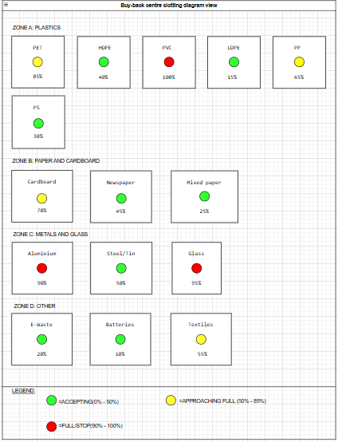

USER INTERFACE
Role-Based Views
Waste Picker (View Only – via kiosk or staff)
- Income board (chart + table)
- Transaction history
User (Buy-Back Centre Staff)
- Dashboard: Quick transaction form
- Register new picker
- View price list (read-only, unless Admin)
- Income board for any picker
- Environmental dashboard
- Map of centres
Admin (Manages 1 or more centres)
- All User features +
- Edit material prices
- View all transactions across centres they manage
Super Admin
- All Admin features +
- Add/edit buy-back centres
- Manage user accounts (create/disable/delete)
- View full audit log(recorded transactions and changes to the system)

USER MAIN SCREENS
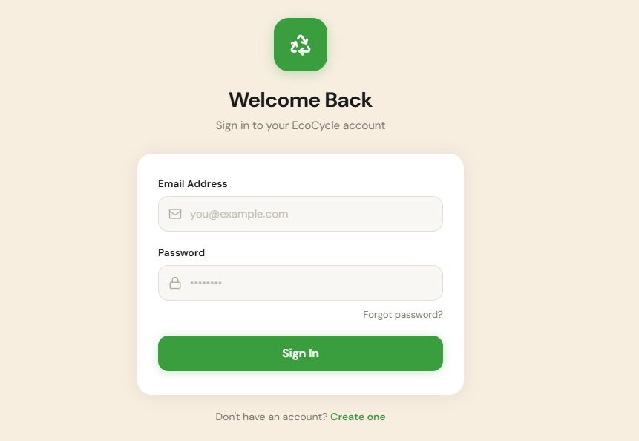
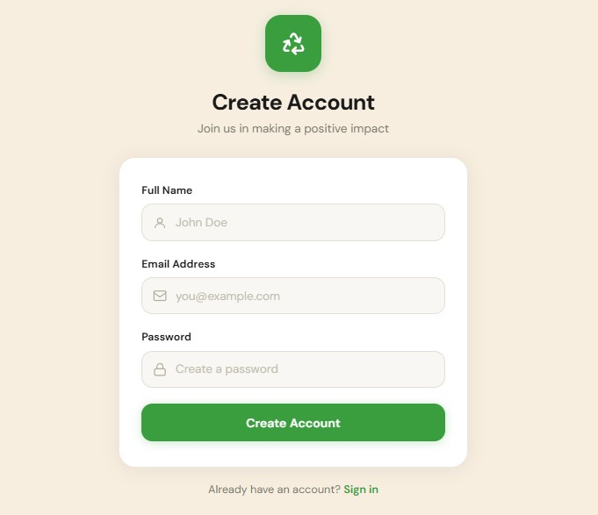
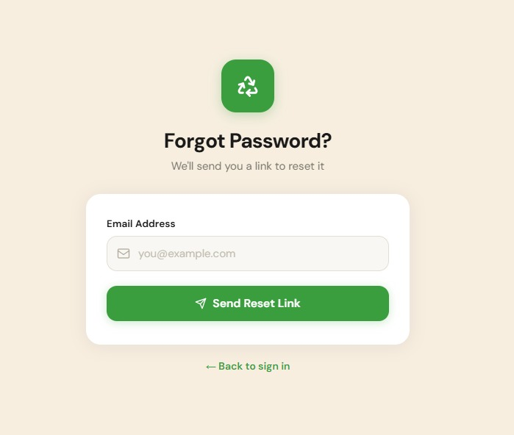
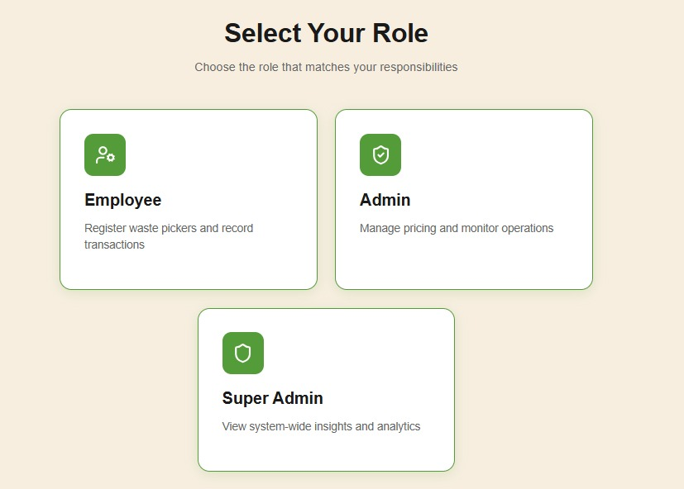
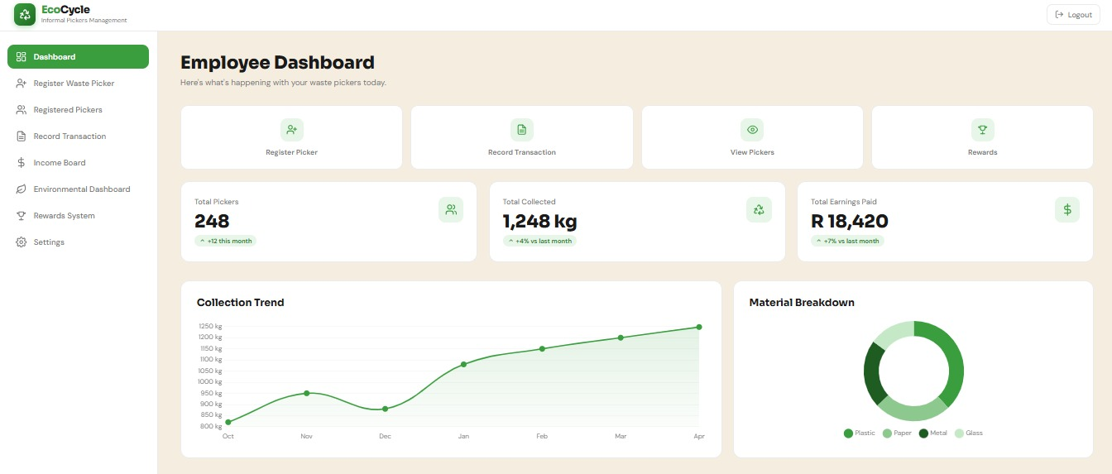
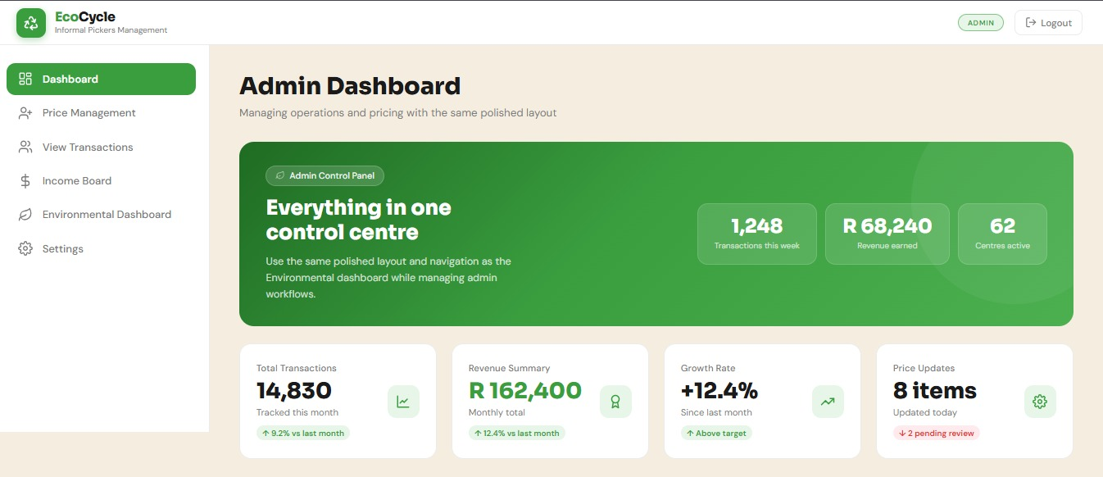
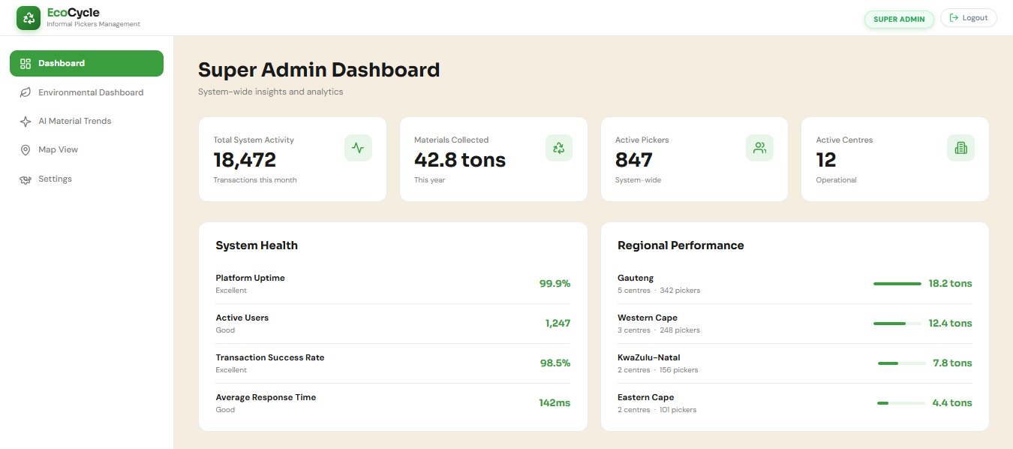
RESPONSIVENESS
Mobile-first responsive design
Most buy-back centre staff use mobile phones. We used the CSS grid and flexbox to ensure that forms and tables are usable on small screens. The body font also changes according to the screen size. If the width of the device’s screen is 568px or less, the font size reduces to 16px, and if the width of the device’s screen is 280px or less, the font size reduces to 14px.

CONCLUSION
The EcoCycle system was designed to improve the management of recycling buy-back centre operations by providing a centralized platform for recording transactions, managing waste picker information, and monitoring recycling activities. The system promotes transparency, efficiency, and better record keeping while supporting environmental sustainability initiatives.
Through features such as transaction management, reward tracking, environmental monitoring, and role-based access control, EcoCycle provides a practical solution for addressing challenges within the informal recycling sector. The proposed system aims to support recycling centres and waste pickers while contributing to a more organized and sustainable recycling ecosystem.

